**SHAITAN KA LAHORE: A JOURNEY THROUGH LAHORE'S PARADOXES**

A Commercial campaign of illustrated books by Sang-e-meel publications.

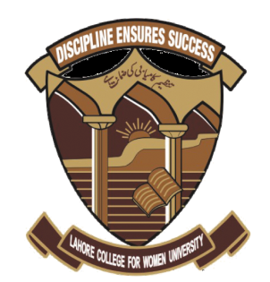

[**A SYNOPSIS SUBMITTED TO LAHORE COLLEGE FOR WOMEN UNIVERSITY IN PARTIAL FULFILMENT OF THE REQUIRMENTS FOR THE DEGREE OF BACHELOR’S IN FINE ARTS (GRAPHIC DESIGN)**](https://en.wikipedia.org/wiki/Bachelor's_degree)

**By**

**Mahira Chaudhry**

**SUPERVISOR**

**Dr. Nida Ijaz**

Assistant Professor

Department of Graphic Design, IDVA, LCWU.

**DEPARTMENT OF GRAPHIC DESIGN, IDVA**

**LAHORE COLLEGE FOR WOMEN UNIVERSITY, LAHORE**

**2024**

**Candidate:**

Name: Mahira Chaudhry

Roll No: 2025140044

Reg. No: 20/LCWU-2021

Session: 2020-2024

**Place of Work:** Department of Graphic Design, Institute of Design and Visual Arts.

Lahore College for Women University, Lahore.

**CONTENTS**

|  |  |  |
| --- | --- | --- |
| **Sr. No.** | **Title** | **Page No.** |
| **1.**  **2.** | List of Abbreviation  Abstract |  |
| **3.** | Introduction | 1 |
| **4.** | Aims and Objectives | 4 |
| **5.** | Review of Literature | 6 |
| **6.** | Methods | 12 |
| **7.** | Bibliography | 16 |
| **8.** | Annexure | III |
|  |  |  |

**LIST OF ABBREVIATION:**

2D: Two Dimensional

HD: High Definition

Publisher: Sang-e-Meel Publications

**ABSTRACT:**

"Shaitan Ka Lahore" tells three interesting stories that examine moral problems and human behavior in the lively city of Lahore. In these stories, characters face tricky situations where they have to decide between honesty and deception. In the first story, "Milawati Achaai," Satan disguises himself to see if people in Lahore are truly good or not. He finds a milk seller who mixes water into his milk and then sells it in cheap prices to poor which challenges our ideas of honesty. The second story, "Ghairat Ka Libadah," shows Satan watching a boy harassing girls but when the same thing happens to his own sister he beats other guys. Lastly, in third story "Sadqa e Dikhawa," Satan visits a government office where he sees a wealthy man taking bribes from poor and afterwards giving large sums of money to charity. These stories humorously highlight the complexities of human nature and moral choices in Lahore.

**CHAPTER NO.1**

**INTRODUCTION**

**INTRODUCTION:**

Children’s illustrated books are the type of literature that narrates children and their world, their interests, their feelings and opinions. It is impossible to ignore that the works of children’s story books have a vital effect on children. The key to becoming a part of the fictional world is to identify with the character It is in early childhood period that one forms an emotional bond and attachment with books and learns from them which as a result outlines tier whole life and their behaviors. When the child reads or is read a written work, the heroes, villains, their points of view about things that happen, the messages given there become an element of identification for the child and his or her personality.

Since they are born, children have equal personality rights with adults and require proper guidance be it in the form of illustrated story books so that it is easier and more fun to learn about world and specific behaviors and how to spend life in better ways.

Children’s rights can be classified in the CRC (The Committee on the Rights of the Child) as follows:

**Living Rights:** They are the rights of children to live, to have proper living standards and to meet their basic needs, such as medical care, food, shelter.

**Development Rights**: They are the rights of children to get education, to play and rest, to get informed, to have freedom of religion, conscience and opinion.

**Protection Rights:** They are the rights of children to be protected against any kind of ignorance or negligence, abuse and exploitation. These rights help protect children in matters such as child labor, physical, emotional and sexual abuse, drug addiction and special care for refugee children.

**Participation Rights:** These rights aim to help children achieve an active role in the family and in society. These are the rights of children to showcase their opinions, to participate in the decisions that affect them, to set up an association and get to together peacefully.[[1]](#footnote-2)

This thesis showcases some issues happening in, well it happens everywhere but especially in, Pakistan, but specifically about some issues that are in Lahore and faced by many.

**IMPORTANCE OF ILLUSTRATED STORY BOOKS:**

Illustrated story books are very crucial in children's life as they are fun to watch as well as read and children learn fast by seeing creative visuals of the words they are reading as Megan Daley says, “Picture books are works of art which should adorn the walls of art galleries and libraries.”

Illustrations provide young people to understand clearly about what the characters look like and what their nature shows and children instantly relate to those characters and scenes from their visual appeal.

Characters work as a vessel for delivering a story to the person who is consuming the media the character is in. However, to do that the character needs to be relatable to the audience. This can be achieved by establishing the character's personality, as it helps to make the character feel more like an actual person.[[2]](#footnote-3)

Even young readers expect the illustrations to provide information that will help them identify text words, either by providing direct information of the object or action, or by providing a context that supports written words. [[3]](#footnote-4)

That is why there are illustrations in this thesis story books so that young readers get a better and clearer idea of what the designer/author actually wants to convey to them and what the actual message is. Local visuals are used so that children can relate more with them.

**CHAPTER NO.2**

**AIMS AND OBJECTIVES**

**AIMS AND OBJECTIVES:**

**AIMS:**

The story aims to dig deep into what's right and wrong, questioning the basic ideas about good and bad. Using Lahore as a backdrop (the time and geographic location within a narrative, either non-fiction or fiction), it aims to show how certain situations and beliefs can affect people on deciding what is right or wrong. The characters in the story change and grow, especially in how they see what's right or wrong. It also wants the readers to think about their own beliefs and consider all angles of the plot. It shows Lahore’s beauty as well as its people and shows harsh reality about them at the same time. Instead of clear-cut good or bad situations, it explores the tricky parts where it's hard to decide what's right. The goal is to educate young readers on what to do in these kinds of situations as no matter what happens they should never deviate from what’s right and wrong.

It leaves a strong impression, making readers keep thinking about the ideas in the story even after they finish reading by challenging them to think in detail about the complexities of human nature.

**OBJECTIVES:**

* Does the story aim to look closely at what is considered good or bad? Does it challenge the usual ideas we have about right and wrong?
* Did the story make readers think more about how to judge and understand others and know their true motive? Is the story about how some things aren't clearly good or bad? Does it show that there are situations where it's hard to decide what's right?
* Does the story want to make readers think about the characters' choices as to why they did what they did?
* Does the end of the story stick with readers even after they finish it? Does it make them keep thinking about the ideas in the story?
* Did the young readers get the conveyed message clearly as to how the good deeds are actually done to get reward from God?

**CHAPTER NO.3**

**REVIEW OF LITERATURE**

**LITERATURE REVIEW:**

The **bribe-taker’s** motivation is to great lengths and is purely a problem of psychology. Taking bribes itself indicates that a person has problems (unsatisfied needs). These days the issues of physical survival due to lack of financing (according to Maslow – physiological needs) currently are not important for officials as they get proper financing. So, we need to analyze that person’s psychological needs. In this aspect it must be concluded that in any case the fact that bribe taking is a proof that the person’s life philosophy has failed. Exaggerated desires for material benefits in the bribe-taker’s personality may form under influence of several reasons such as sublimation (mature type of defense mechanism, in which socially unacceptable impulses or idealizations are transformed into socially acceptable actions or behavior) of childhood fear and poverty, search for safety, willingness to overcome the sense of weakness, feeling of being unprotected, being inferior, will for power, etc.[[4]](#footnote-5)

**Milk** is a wholesome and nutritious dairy product and is taken by almost all of the population around the world for drinking as it is, as well as via dairy products. However, the practice of adulteration (The process of intentionally degrading milk quality either by adding some inferior substances or by removing some valuable ingredient) of milk invariably reduces its quality and may introduce health danger substances into the dairy supply chain disturbing its consumers’ health. Many instances of adulteration of milk have been reported around the world, in which substances such as water, external proteins, whey proteins, melamine and urea, vegetable or -

animal fats, plus many minor constituents of milk fat have been added as potential adulterants in milk and milk products.[[5]](#footnote-6)

**Harassment** is unwanted sexual attention. It is a type of harassment that all women are affected by, regardless of age, race, color, class, and religion. Harassment is a dirty method used by men to show their dominance over females. Harassment happens everywhere, from home to the office. During their daily travel, females face harassment. Due to this reason, females are hesitant to travel on public transports. Females not only experience harassment in workplaces; **92%** of females from low-income families experience harassment using public transportation. In **Pakistan**, public transport is a usual means of transportation for low-income groups because of low fares. Females from low-income face harassment daily because of daily subjection to public transport. Most people in public places are men. They serve as both allies and harassers. The male passengers who see the harassment remain mute, which gives the harassers the sense that their behavior is normal and gives them the courage to continue. Because there is not a specific area for women in trains and buses, majority of the female passengers experience the worst harassment.[[6]](#footnote-7)

Picture books play an important role in giving out unforgettable social information about people's actions, impacting students' grasp of the language used to communicate such information. Moreover, they encourage an adjustable and open mindset required for gripping knowledge in various content areas. Due to this, picture books serve as valuable assets in

classrooms, offering vast perspectives on social concepts. They increase understanding by providing in-depth details that textbooks may not have, therefore adding richness to specific topics.[[7]](#footnote-8)

Children learn to remember pictures before they learn to read words. Pictures also are the basis of the earliest records of man's attempts at communication: cave paintings, church murals, stained glass windows-all attest to the importance placed on pictorial representation. It is surprising to realize how long it took for illustration of children's books to gain importance. Early books for the young were not without pictures, but they were not illustrated books.[[8]](#footnote-9)

Some of illustrated urdu story books for children are mentioned below that talk on social and moral issues and educate children for future,

**1) Mera Jism Mera Hai,** by Ashhad Qureshi

Publishing, 2021

**Mera Jism Mera Hai** is an illustrated children’s story book in Urdu, the first of its kind in Pakistan, that helps children and their parents to go through the complicated conversations around body boundaries, personal space, and safety planning as it -

relates to prevention of child sexual abuse. It also consists of activities for children, guidance for their guardians, as well as connects to free mental health resources.[[9]](#footnote-10)

(Fig. 01)

**2) Susti Achi Nahi, By Moazzam Javed Bukhari**

Publishing, 2016

Susti Achi Nahi is Written by Moazzam Javed Bukhari. Susti Achi Nahi is another most beautiful kid's novel that consists of exciting and educational story of such a cat and her kids about slackness and lack of strictness or care in Urdu language.[[10]](#footnote-11) (Fig. 02)

**3) Khatta Bakra, By Amra Alam**

Publishing, 2002

This is a comical book of rhyming and verse about a goat who lives on a tree of lemon. An creative and splendid children's story with eye catching illustrations which are easy to read, simple, charming and keeps little children engaged. This will help growing children to understand and learn the basic values, encourages their imagination, increases curiosity, also helps in developing their brain activity, ability to focus, and concentration, build social skills and

communication skills. Further help them to learn the difference between real and imitation.[[11]](#footnote-12) (Fig. 03)

**4) Ajnabi Dost Nahi, by Jacqueline Mirza**

Publishing, 2017

Will you sit in the car with a stranger? Or tag along with someone who offers you a toy? Using rhyme and verse, this book forewarns children to listen to their parents’ advice and never to follow strangers on the street.[[12]](#footnote-13) (Fig. 04)

**5) Malala Yousafzai: Warrior with Words, by Karen Leggett Abouraya**

Publishing, 2014

Malala Yousafzai grew up in a world where women were supposed to be quiet, but she refused to be silent. She believed that one child, one teacher, one pen and one book can change the world. **Warrior with Words** tells the stimulating story of a brave girl named Malala Yousafzai. The young Pakistani girl stood up for every child’s right to education. On her 16th birthday, nine months after she was shot by Taliban gunman, she spoke at the United Nations. Beautifully –

illustrated, this is an accessible and encouraging book that teaches young children about terrorism, courage and patience.[[13]](#footnote-14)  (Fig. 05)

After doing all this research it is seen that as most people have written about these issues it is noted that majority are from Pakistan and mainly Lahore. Majority have talked about many issues through the use of illustrated story books but no one has talked about major issues faced by people in Lahore such as harassment, adulteration of food especially milk and bribery as well and education and awareness of how to face these situations or how to deal with them is not given to young people and they end up getting caught in these issues where they do not know how to react. Doing bad deeds in a good way or vice versa can never get people anywhere and these story books will help children in great lengths as they are fun to learn and easy to understand.

So, as this thesis is mainly about providing information about these things to young children using illustrated story books, further work can be done on this idea on a large scale internationally.

**CHAPTER NO.4**

**MATERIALS AND METHODS**

**METHODOLOGY:**

As the title shows **shaitan ka Lahore** so this thesis includes three illustrated story books in which three major issues in Lahore are discussed in a form of story. Pakistani theme is shown in these story books and will show Pakistani culture. Through that viewers can relate with how Pakistani streets look and feel.

The background story of these three books is that Satan got some information from his servants that there are increase of people coming here after dying but they are claiming that they did all good things in life, and they actually did good deeds then why are they here as ultimately, they were good in life. So, Satan was very confused as ell and as a result he decided to visit Lahori streets to see what actually was happening.

**First story book** is on **milawati achaai** in which the Satan visits Lahore and he first sees a shop of doodhwala where he sells milk. His sole purpose of coming to Lahore was to see that it has been decade since he personally visited Lahore and there has been commotion in heaven and hell as to whether the people here are doing good things or bad as Satan sees good as good and bad as bad deeds but he got information that people have adopted new methods as they are doing good deeds in bad ways and vice versa so he visits Lahore to see what the problem was .

He first visits **doodhwala** and he notices that on his shop is written **bismillah** in bold and clear letters and what he is doing inside shocks the Satan that he is mixing milk with water that shows that he claims to people that he is very righteous by choosing that name for his shop when he

himself is doing that bad deed but also selling milk in cheap prices to poor. So, Satan is confused whether to see it as good deed or bad

Then **second story book** is about **ghairat ka libadah** in which he visits speedo stop while waiting for speedo and what he sees next intrigues him that boys are harassing girls and touching them in wrong way so he follows one of the guys and sees that when some other guy touched that guy's sister he gets furious and beats other guys over that and Satan gets confused that he is doing good by keeping bad guys away from his sister and bad deed by touching others' sisters.

Then **third story book** is about **sadqa e dikhawa** in which Satan follows a wealthy man in a government office while contemplating that how low the Muslims have fallen and he sees that man taking bribes from poor in order to resolve their issues and then afterwards just to show off in front of the world that how righteous he is he sends his majority money to charity.

In the end all this confuses Satan so much that as world has evolved so as the people but they have adopted new ways of sins and they just justify themselves that they are doing good instead of bad by doing good but in bad way so all their good deeds are wasted and no reward is given to them by Allah. Satan keeps talking to himself that if only they got to know how things actually work and that bad is bad no matter what then they would never do such things. The things that are forbidden will always remain forbidden.

When Satan sees good deeds done in bad way and bad deeds in good way, he is confused very much but when he came back to hell, he thought hard about what he experienced and saw in Lahore and after analyzing each and everything he came to the conclusion good are good and bad deeds are bad no matter what. Satan realizes that things are not always as to the point as

good or bad. People in Lahore, like everywhere else, are complicated, and their actions do not always fit nearly into categories so instead of judging them by their appearance and status, it is important to understand the reasons behind their choices.

These story books encourage its young readers to look beyond physical appearances and consider the complexities of human behavior, nature and decisions. They suggest that being understanding and compassionate is important when trying to make sense of the sometimes-confusing mixture of good and bad in people's actions.

The execution of these story books will be based on very soft and easy to understand illustrations and words as the books are for young readers and the main focus will be the way to make them understands the actual message and story with the help of vibrant color palette and fun illustrations.

**Medium:**

Print with illustrations in 2D style.

**Marketing Strategy:**

Outdoor Campaign.

* Character Standees.
* stickers
* Books.
* Posters.
* bookmarks
* Invitation card
* Gift paper.
* School book labels.
* Puzzles
* topic flex

**SOFTWARE:**

Photoshop

Illustrator

Canva

**TARGET AUDIENCE:**

Children aged 10 years and above are the target audience for these story books as these books educates them about complex human nature and difference between right and wrong and another

plus point for these story books is their plot that anyone can read them such as children because of fun story plots and illustrations as well as teenagers as these issues are faced by everyone from any age group especially harassment.

**CHAPTER NO.5**

**REFERENCES**

Muhammed Ubaydullah, “The Analysis of Illustrated Story Books for Children Aged 3-6 in Terms of Protection Rights”, last updated on October 25, 2023, <https://dergipark.org.tr/en/download/article-file/3492800> (accessed on March 10, 2024)

Janina Tiainen , “Conveying Character Personality Through Illustration”, last updated in 2020, <https://www.theseus.fi/bitstream/handle/10024/340717/Thesis_JaninaTiainen.pdf?sequence=2&isAllowed=y> (accessed on March 10, 2024)

Karen M. Feathers & Poonam Arya , “The Role of Illustrations During Children’s Reading”, last updated in 2012, <https://www.researchgate.net/profile/Poonam-Arya 4/publication/343323340_He_did_like_this_against_the_tree_The_Role_of_Illustrations_during_Independent_Reading/links/5f2333baa6fdcccc439bd4d9/He-did-like-this-against-the-tree-The-Role-of-Illustrations-during-Independent-Reading.pdf> (accessed on March 10, 2024)

A. Krivins , “The motivational peculiarities of bribe-takers”, last updated on January 31, 2018, <https://www.shs-conferences.org/articles/shsconf/pdf/2018/01/shsconf_shw2018_01006.pdf> (accessed on March 12, 2024)

Amrita Poonia, Alok Jha, Rajan Sharma, Harikesh Bahadur Singh, Ashwini Kumar Rai, Nitya Sharma, “Detection of adulteration in milk: A review”, last updated on November 4, 2016, ,<https://onlinelibrary.wiley.com/doi/epdf/10.1111/1471-0307.12274> (accessed on March 12, 2024)

Sunana Alam, Shehla A. Yasin, “Harassment Faced by Females at Bus Stops in Lahore”, last updated on January 31, 2018, <https://jprpk.com/index.php/jpr/article/view/206/291> (accessed on March 12, 2024)

Pamela J. Farns, Carol J. Fuhler, “Developing social studies concepts through picture books”, last updated on February 1994, <https://www.jstor.org/stable/20201271?seq=5> (accessed on March 12, 2024)

Joyce Irene Whalley, “The development of illustrated texts and picture books”, last updated in September 2, 2003, <https://www.taylorfrancis.com/chapters/edit/10.4324/9781315015729-24/development-illustrated-texts-picture-books-joyce-irene-whalley> (accessed on March 12, 2024)

Ashhad Qureshi, “Mera Jism Mera Hai”, Published on July 7, 2021, [https://www.merajismmerahai.com/](https://www.jstor.org/stable/20201271?seq=5) (accessed on March 21, 2024)

Moazzam Javed Bukhari, “Susti Achi Nahi”, Published on July 20, 2016,

[https;//pdfbooksfree.pk/susti-achi-nahi-by-moazzam-javed-bukhari/](https://www.jstor.org/stable/20201271?seq=5) (accessed on March 21, 2024)

Amra Alam, “Khatta Bakra”, Published on January 1, 2002,

<https://kidscare.pk/products/khatta-bakra-urdu-story-book> (accessed on March 21, 2024)

Jacqueline Mirza, “Ajnabi Dost Nahi”, Published on January 1, 2017,

[https://www.urdubazaar.ca/products/ajnabi-dost-nahi-%D8%A7%D8%AC%D9%86%D8%A8%DB%8C-%D8%AF%D9%88%D8%B3%D8%AA-%D9%86%DB%81%DB%8C%DA%BA](https://www.urdubazaar.ca/products/ajnabi-dost-nahi-اجنبی-دوست-نہیں) (accessed on March 21, 2024)

Leggett Abouraya, “Malala Yousafzai: Warrior with Words”, Published on January 29, 2014, <https://coloursofus.com/childrens-books-set-in-pakistan/> (accessed on March 21, 2024)

**CHAPTER NO.6**

**ANNEXURES**

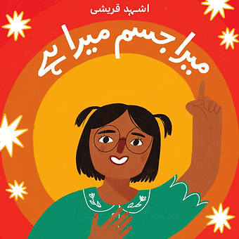

Figure 1:Mera Jism Mera Hai, by Ashhad Qureshi, Daastan, 2021 <https://www.merajismmerahai.com/> (accessed on March 21, 2023)

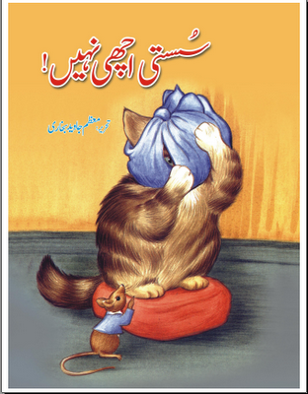

Figure 2: Susti Achi Nahi, By Moazzam Javed Bukhari, 2016 <https://pdfbooksfree.pk/susti-achi-nahi-by-moazzam-javed-bukhari/> (accessed on March 22, 2023)

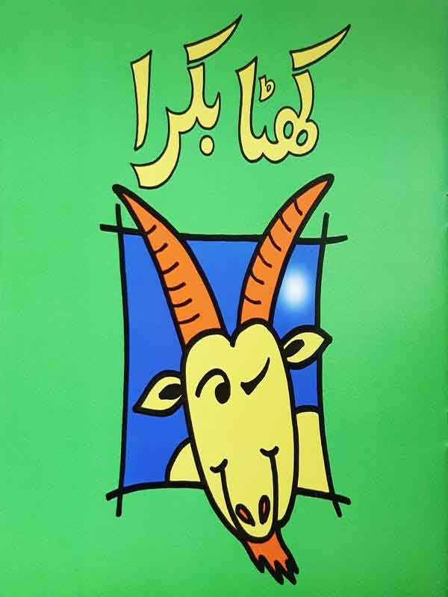

Figure 3: Khatta Bakra, By Amra Alam, The Book Group, 2002 <https://kidscare.pk/products/khatta-bakra-urdu-story-book> (accessed on March 22, 2024)

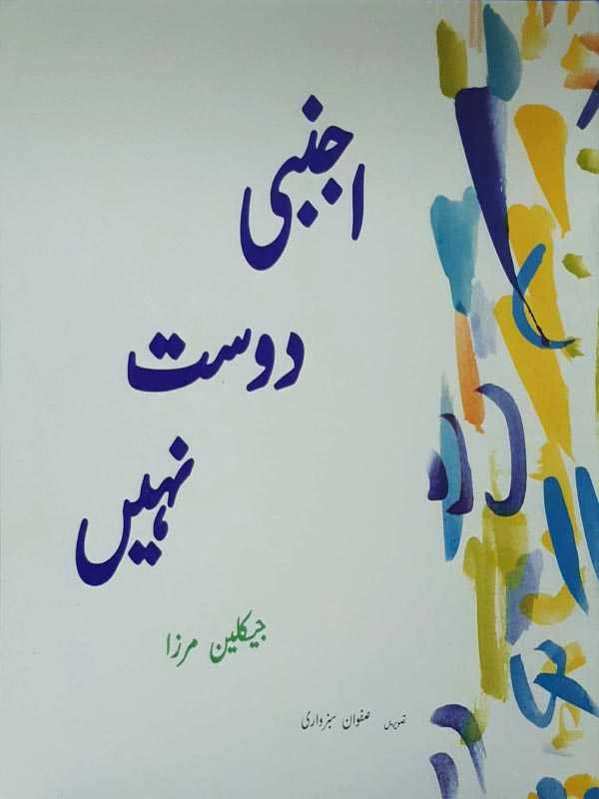

Figure 4: Ajnabi Dost Nahi, by Jacqueline Mirza, The Book Group, 2017 [https://www.urdubazaar.ca/products/ajnabi-dost-nahi-%D8%A7%D8%AC%D9%86%D8%A8%DB%8C-%D8%AF%D9%88%D8%B3%D8%AA-%D9%86%DB%81%DB%8C%DA%BA](https://www.urdubazaar.ca/products/ajnabi-dost-nahi-اجنبی-دوست-نہیں) (accessed on March 22, 2024)

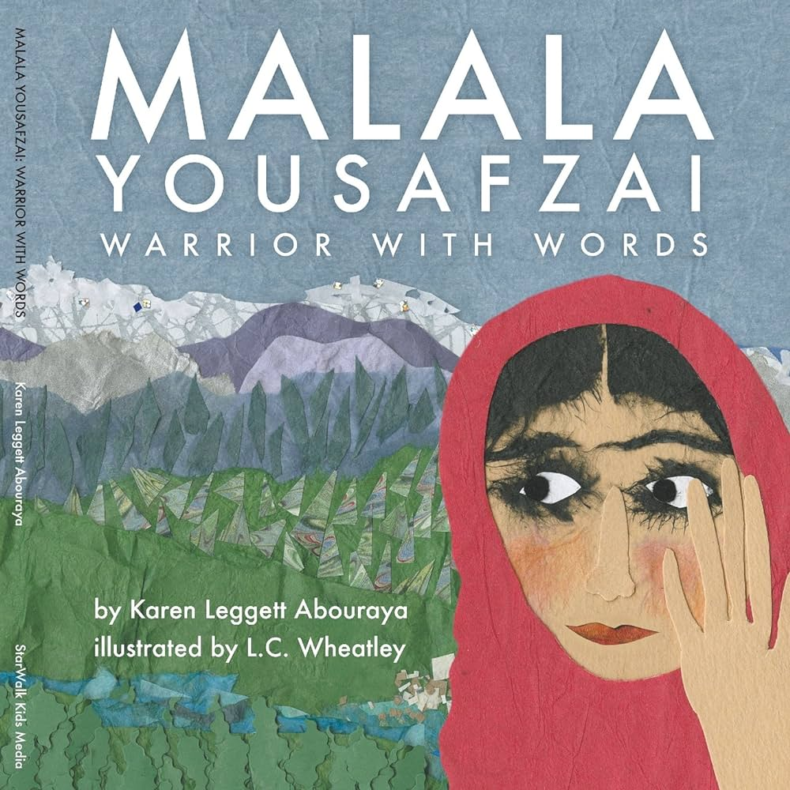

Figure 5: Malala Yousafzai: Warrior with Words, by Karen Leggett Abouraya, Lee & Low Books, 2016 <https://www.amazon.com/Malala-Yousafzai-Karen-Leggett-Abouraya/dp/1630833169> (accessed on March 22, 2024)

1. Muhammed Ubaydullah, “The Analysis of Illustrated Story Books for Children Aged 3-6 in Terms of Protection Rights”, last updated on October 25, 2023, <https://dergipark.org.tr/en/download/article-file/3492800>

   (accessed on March 10, 2024) [↑](#footnote-ref-2)
2. Janina Tiainen , “Conveying Character Personality Through Illustration”, last updated in 2020, <https://www.theseus.fi/bitstream/handle/10024/340717/Thesis_JaninaTiainen.pdf?sequence=2&isAllowed=y> (accessed on March 10, 2024) [↑](#footnote-ref-3)
3. Karen M. Feathers & Poonam Arya , “The Role of Illustrations During Children’s Reading”, last updated in 2012, <https://www.researchgate.net/profile/Poonam-Arya-4/publication/343323340_He_did_like_this_against_the_tree_The_Role_of_Illustrations_during_Independent_Reading/links/5f2333baa6fdcccc439bd4d9/He-did-like-this-against-the-tree-The-Role-of-Illustrations-during-Independent-Reading.pdf> (accessed on March 10, 2024) [↑](#footnote-ref-4)
4. A. Krivins , “The motivational peculiarities of bribe-takers”, last updated on January 31, 2018, <https://www.shs-conferences.org/articles/shsconf/pdf/2018/01/shsconf_shw2018_01006.pdf> (accessed on March 12, 2024) [↑](#footnote-ref-5)
5. Amrita Poonia, Alok Jha, Rajan Sharma, Harikesh Bahadur Singh, Ashwini Kumar Rai, Nitya Sharma, “Detection of adulteration in milk: A review”, last updated on November 4, 2016, <https://onlinelibrary.wiley.com/doi/epdf/10.1111/1471-0307.12274> (accessed on March 12, 2024) [↑](#footnote-ref-6)
6. Sunana Alam, Shehla A. Yasin, “Harassment Faced by Females at Bus Stops in Lahore”, last updated on January 31, 2018, <https://jprpk.com/index.php/jpr/article/view/206/291> (accessed on March 12, 2024) [↑](#footnote-ref-7)
7. Pamela J. Farns, Carol J. Fuhler, “Developing social studies concepts through picture books”, last updated on February 1994, <https://www.jstor.org/stable/20201271?seq=5> (accessed on March 12, 2024) [↑](#footnote-ref-8)
8. Joyce Irene Whalley, “The development of illustrated texts and picture books”, last updated in September 2, 2003, <https://www.taylorfrancis.com/chapters/edit/10.4324/9781315015729-24/development-illustrated-texts-picture-books-joyce-irene-whalley> (accessed on March 12, 2024) [↑](#footnote-ref-9)
9. Ashhad Qureshi, “Mera Jism Mera Hai”, Published on July 7, 2021, [https;//www.merajismmerahai.com](http://www.merajismmerahai.com/) (accessed on March 21, 2024) [↑](#footnote-ref-10)
10. Moazzam Javed Bukhari, “Susti Achi Nahi”, Published on July 20, 2016, <https://pdfbooksfree.pk/susti-achi-nahi-by-moazzam-javed-bukhari/> (accessed on March 21, 2024) [↑](#footnote-ref-11)
11. Amra Alam, “Khatta Bakra”, Published on January 1, 2002,

    <https://kidscare.pk/products/khatta-bakra-urdu-story-book> (accessed on March 22, 2024) [↑](#footnote-ref-12)
12. Jacqueline Mirza, “Ajnabi Dost Nahi”, Published on January 1, 2017,

    [https://www.urdubazaar.ca/products/ajnabi-dost-nahi-%D8%A7%D8%AC%D9%86%D8%A8%DB%8C-%D8%AF%D9%88%D8%B3%D8%AA-%D9%86%DB%81%DB%8C%DA%BA](https://www.urdubazaar.ca/products/ajnabi-dost-nahi-اجنبی-دوست-نہیں) (accessed on March 22, 2024) [↑](#footnote-ref-13)
13. Leggett Abouraya, “Malala Yousafzai: Warrior with Words”, Published on January 29, 2014, <https://coloursofus.com/childrens-books-set-in-pakistan/> (accessed on March 22, 2024) [↑](#footnote-ref-14)